Web app dev lab 7 homework
- Advance search:
- Multi-criteria Search:
Access localhost:8080/products, the user can see an "Advanced Search" section. After user inputs something into it and clicks apply filter button browser sends a GET request to /products/advanced-search. The controller layer receives the request and calls the service layer method advancedSearch(). Then the service layer then calls productRepository.searchProducts() to execute SQL query at database layer and finally return results as a list of product and delivery back to view layer for visualization. 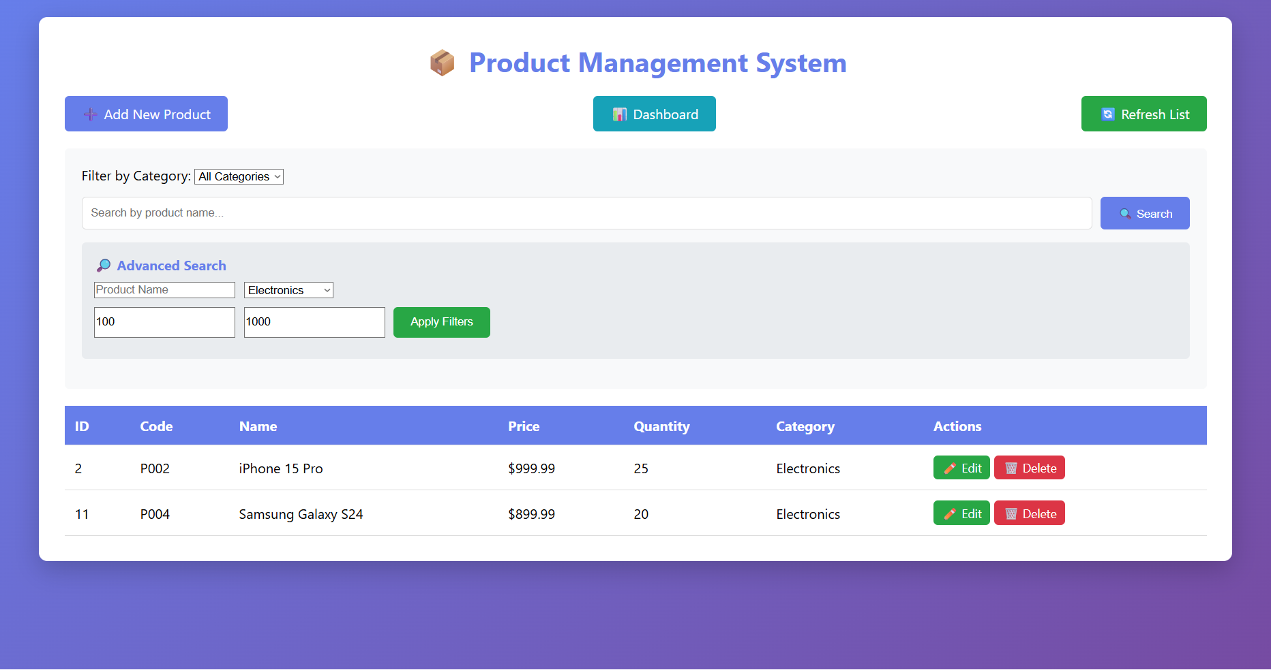

- Category filter:
At “Advance search” section, user can see a dropdown box for category filter. When the user selects a category from the dropdown, JavaScript auto-submits the form sending a GET request to /products?category=(something that user chooses). And then the controller layer receives the category parameter in listProducts() method and calls productService.getProductsByCategory(category) which will ask service layer to calls productRepository.findByCategory() for execute SQL query at database layer. The filtered list will be return through service layer and the view layer will display to user.
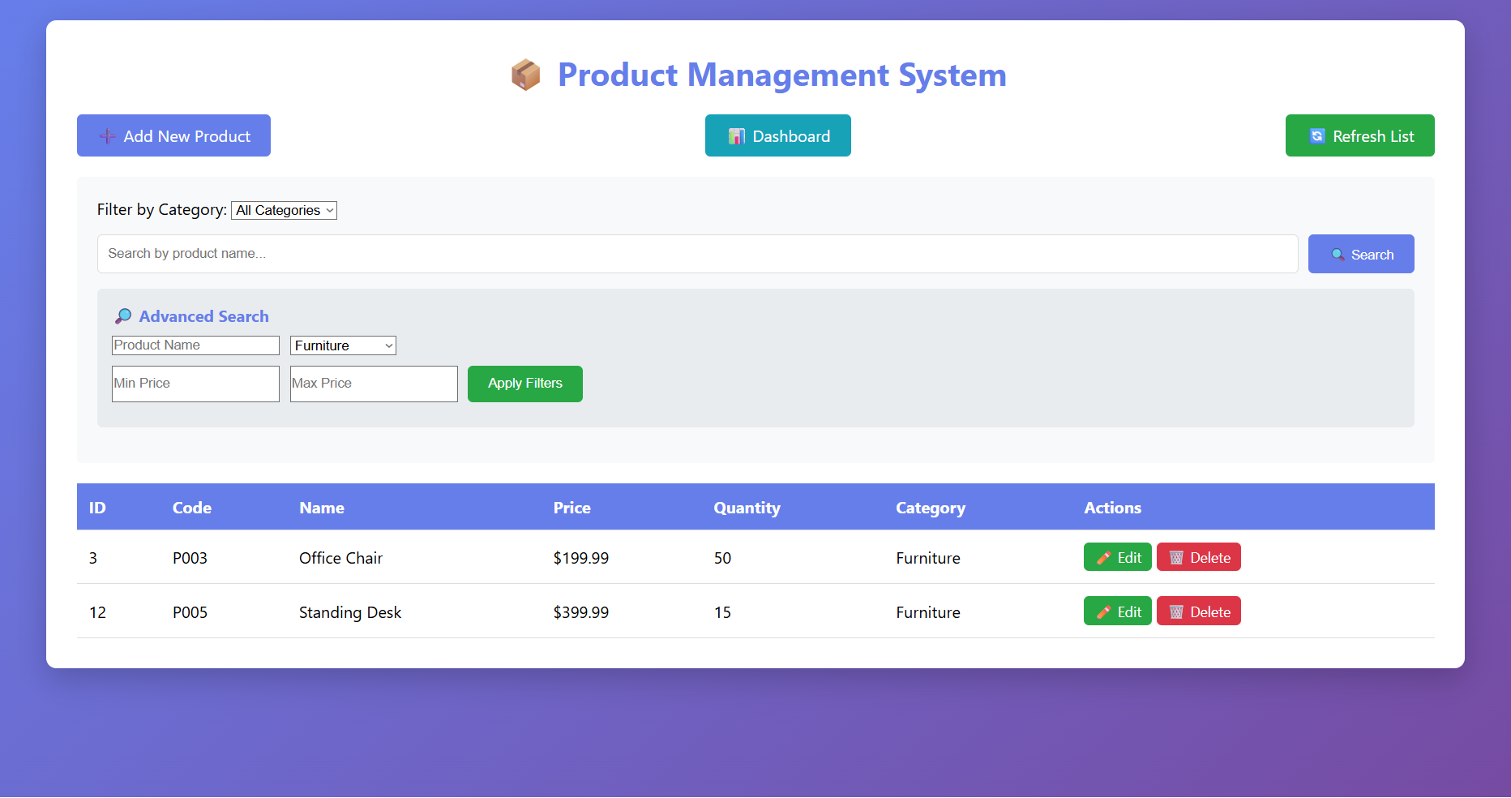

- Validation:

